

# BCS503 - Software Engineering

**SMART LIBRARY**

|  |  |
| --- | --- |
| **NAME** | **MATRIC NO** |
| **DINESH** | **201800242** |
| **TANESH SHANKER KUMAR** | **SES 181010** |
| **SKANDHAROOPAN** | **SES 181008** |

**TABLE OF CONTENT**

|  |  |  |
| --- | --- | --- |
| **NO** | **TITLE** | **PAGE** |
| 1 | INTRODUCTION | 1 |
| 2 | PROBLEM STATEMENT | 2 |
| 3 | OBJECTIVES | 3 |
| 4 | SYSTEM REQUIREMENT | 4 - 6 |
| 5 | ARCHITURTURE DIAGRAM | 7 |
| 6 | PROTOTYPE | 8 - 13 |
| 7 | TEST DESIGN | 14 |
| 8 | REFERENCES |  |

**INTRODUCTION**

This paper describes the need to use personal accounts of users to introduce innovative library and information services at universities.The research is designed to provide libraries with a smart library management application.in any educational organization, the library is one of the important parts. Although library has a system, a new management system must be implemented by the library to replace the existing system by introducing the new system. There are many reasons why library staff need to implement a different system ;which are time taken to search a particular book in particular shelf ,time taken done a specific task ,difficulty in updating the information on regular basis and extra to overcome this problem we need to come up with new solution that is smart library .Our study's main goal is to create a prototype for a mobile application. Automate the library system without human assistance, reduce time and provide security.This prototype figures out all the facilities that we include in our system. This prototype mainly designed to make works more easier such as updating books record ,records of including adding and removing books, track book’s transaction information,extend the time period of bored books, availability of the books for borrowing, all the bookings for PC ,discussion rooms ,and all.

This mobile application needs internet to access the server. The user need to download this app by using the QR code. This QR code will be in every student identification card ;or they can scan in their library. Once they download this app they have to sign up to create their personal accounts by using only their student email address or staff email address. All the users need to sign up for their first time use only. once their sign up they can log in via their personal email address and password .if the user forget their password they can reset it via 4 digit secret code which will sent through their email address.This allows us to significantly extend library opening hours, so more people can use the library at times that is convenient for them.The new system will manage and control all library information, solve the above-mentioned problems and provide the staff & students with several benefits.

**PROBLEM STATEMENT**

The major problem of a library **is  maintaining the book record including adding, removing, and updating books record** .There is a lot of **possibility of the books get misplaced** and the search for the books becomes big issue for both the librarian and the user.besides that **tract book’s transaction information** which is number of books that is being used by students and teacher was also a major problem.Students pick the books from the shelf, then they **does not put back at the proper place after use**.this unmoral behaviour gives difficulties to other student when they search for the books.

Finally Library staffs are not able to provide the **accurate information about the books** for the lecturers and students as they find the difficulties on update the information on a regular basis.besides that thecategories of books.some of students might be don’t know the **category of the books they search for.**in this case they have to spend more time to search for the particular book.**the books are not according to the cours**e as it is difficult for the students to find the material for their revision.and the books that are placed in the library are **not according to the subject**.these leads difficulties for the students to do revision for their exam.it is difficult for the students to print out their materials as the **printing machine in the library is in out of service**. As there are **lack of printing machines** in the library, it is hectic for the student to queue up for a long hours to print their material.there is **lack of computer** in library as there no the space for students to use it when it is needed for them.the scaning machines could not detect the **bar code of the book** which had been borrowed by the students.therefore the students could not borrow the book on time when they are need it.The **detecting scanner for the theft of the book is unable to detect** the theft appropriately .therefore the number of books in the library is decreasing by day to day due to the theft.there are **lack of discussion room** in the library as it is difficult for the students to reserve the discussion when they are in need .**there is so much of noises in library**.

Therefore this assignment is mainly to overcome this problems and make it as how a smart library really looks like .our main goal is to create a prototype for a mobile application to overcome all this problems .this application will solve all the above mentioned problems.There will be a proper record of the books which people search for. This app consist the list of books ,**who borrowed the book? when they returned ,extend the borrowed book period ,booking the pc ,discussion room ,carrrel room early, checking the updates,news feed ,remainder of library opening and closing for the public holidays**.our main aim is to Improve the facilities through IoT. this app will surely help the users to get enough information and make their life more easier .

**OBJECTIVES**

1. Modernize the information technology infrastructure of the library and provide

state-of-the-art technological to improve access to electronic materials and media

1. Improve the functions of library through IoT
2. Provide superior access to materials needed by our students, faculty and staff
3. Design services and resources concepts to keep users coming back to the library
4. Make students life more easier

**SYSTEM REQUIREMENT**

**Login system -** Students, Lecturers, and administrators are required to input their name and password in the login screen in order for them to access into the Smart Library System. If the login is unsuccessful, it will indicate as a message as an invalid user account, so the user has to login again in order to access into the Smart Library System.

**Sign Up system -** Students, Lecturers, and administrators are required to sign up using their details, for example, their full name, username, ID number and also their email to sign up for the Smart Library System. If their sign up is successful, verification is sent to their email for us to confirm that they are using their own email.

**Online Cloud backup -** The system will have Online Cloud backup in order for the user to recover their documents and their accounts details. They can recover it in any device they want and whenever they need the document.

**Feedback forum -** The users can send feedbacks and ratings regarding how the system works and is there any improvements that need to be made.

**Activity History -** Users can view the list of books that they have borrowed soo far and the reports that they have made.

**Notification -** Users will get a notification if there is any report that has been made if the library is too noisy and if the due date of their books that needs to be returned which they borrowed and also if their due time is finishing if they are using the computer systems there.

**Updates -** Users will get updates if there is any new books are available

**Functional Requirements**

**Login Page**

To allow users to view their respective page

**User creation**

To allow users to sign up using their ID number to create an account

**Landing page**

The main page after their credential verification

**Alert page**

The users are able to click the alert icon if the library is to noisy

**Credentials verification**

Basic security measurements for the users

**Booking view**

Users can view the list of books that they have booked before and they can book any books they want

**Search view**

Users can search for the books that they want to book

**Track view**

Users can track the books which they want to use which will show the direction of the book

**Security**

The information provided by the users will be kept safe

**Non-functional requirements**

**Feedback forum**

Users can give their feedback on how the application works and feedbacks regarding on how to improve the application and they can also report if there is any errors in the application

**Activity History**

Users can view their history of books that they have borrowed and times that they have clicked the alert icon

**Notification**

Users will get a notification when their due date to return of the books is near and if they make lots of noise in the library and if there is any new books are available in the library

**Connection**

Users can only use the application of there is WI-FI connection is connected to their mobile phone

**Services**

Updates will be provided in order to improve the performance of the application and patch up errors in the application.

**Performance**

The application will have a one-click performance in order to avoid lagging performance of the application

**Storage**

Size of the application does not occupy much storage space.

**Accessibility**

Easy to be used and anyone can use this smart library system

**Supportability**

This application supports IOS devices and also android devices.

**ARCHITURTURE DIAGRAM OF THE SYSTEM**

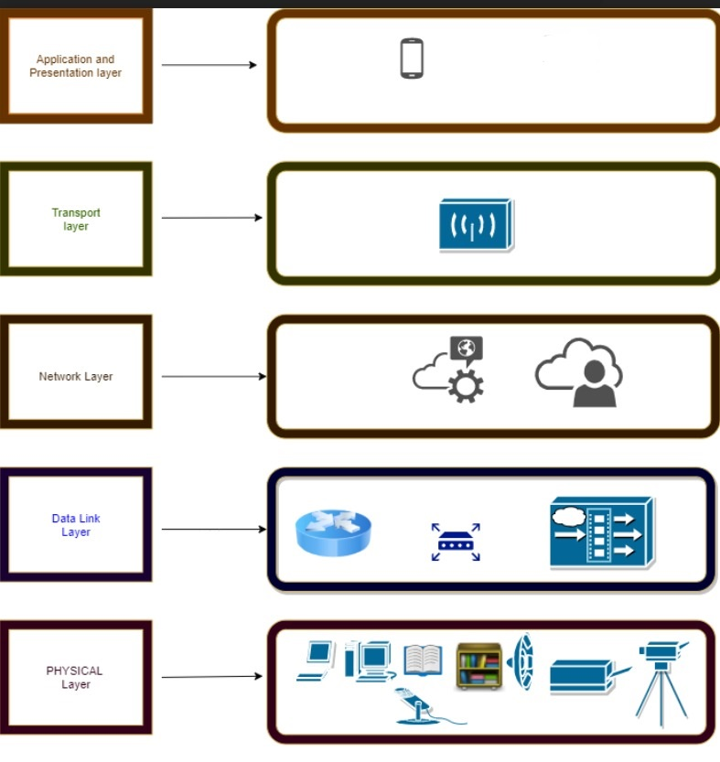

There are total of five layer in this architecture diagram which are application layer, transport layer, network layer, data link layer and physical layer. In the application layer, there are mobile and PC can be our user tool. Then, the transport layer. The transport layer is the layer in the open system interconnection (OSI) model responsible for end-to-end communication over a network ( WIFI ) connection. The third layer is network layer where using the cloud system and also the layer that provides data routing paths for network communication. The data link layer is the protocol layer in a program that handles the moving of data into and out of a physical link in a network. The data link layer is the fourth layer in architecture model for a set of telecommunication protocols. The final layer is the physical layer which having all the functions. Physical layer provides its services to Data link layer.

**PROTOTYPE**

1. **Login** **page**

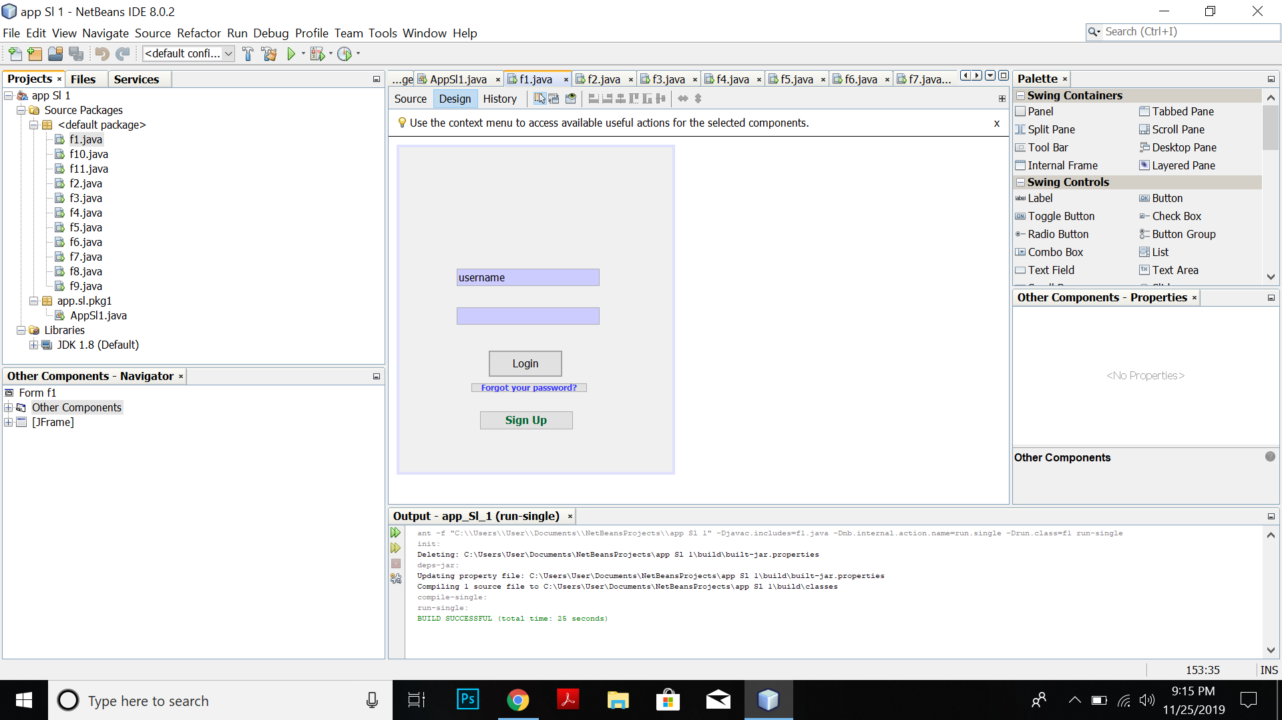

User need to insert username and password to login. There have a **Sign Up button** and also **Forgot your password** option.

1. **Sign Up**

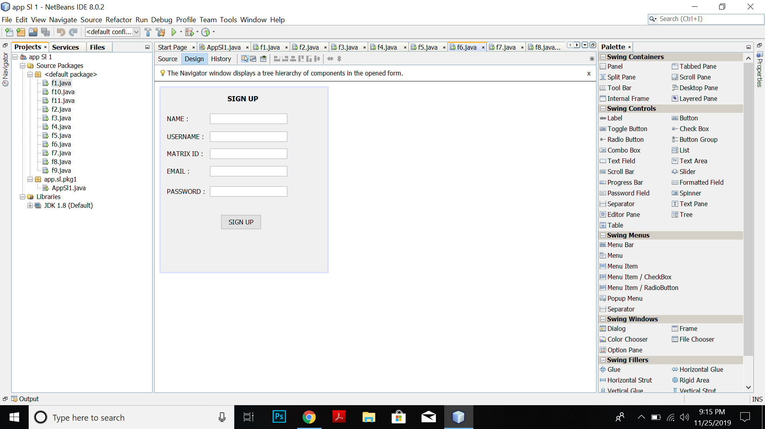

The user need to insert the name, username, matrix id, email and password in order to sign up to the account.

1. **Forgot your password**

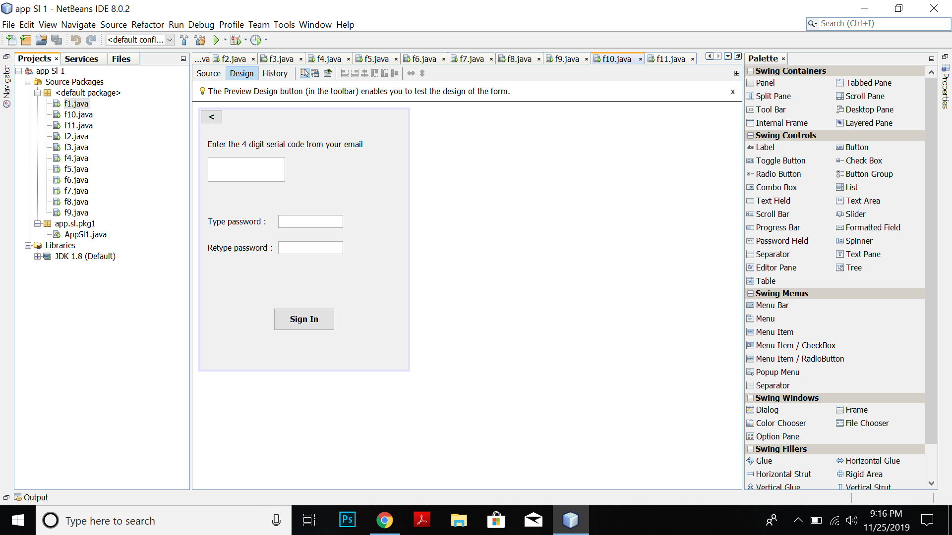

When the user click the **forgot your password** button, it appear like this. The user need to enter 4 digit serial code you received from your email. Then, type the password.

1. **Homepage**

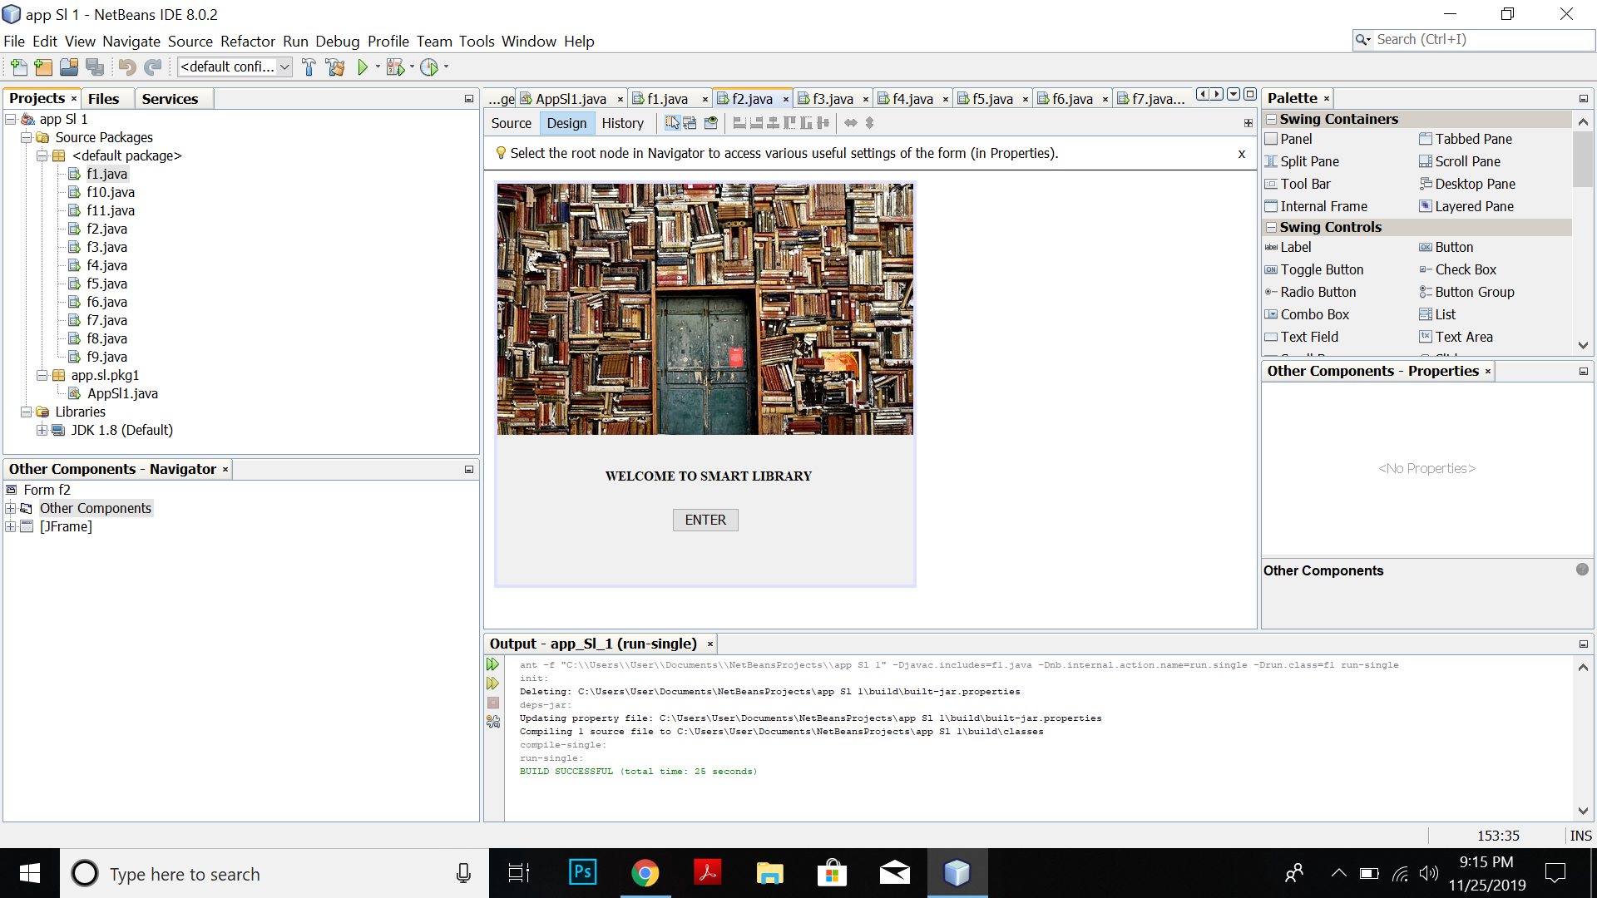

The homepage appeared when the user login

1. **The Options**

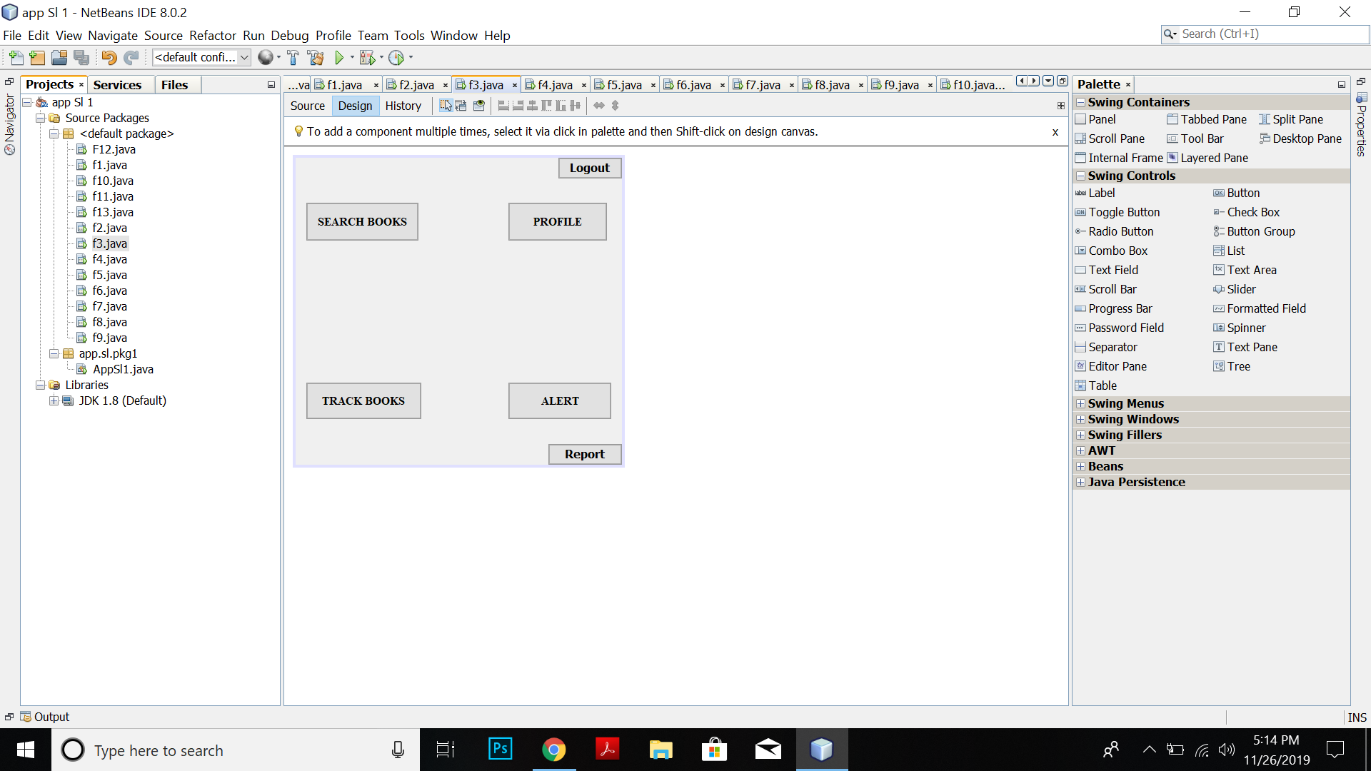

There are 6 options which are **Search books, Profile, Track Books, Alert, Report** and **Logout**.

1. **The Search Books**

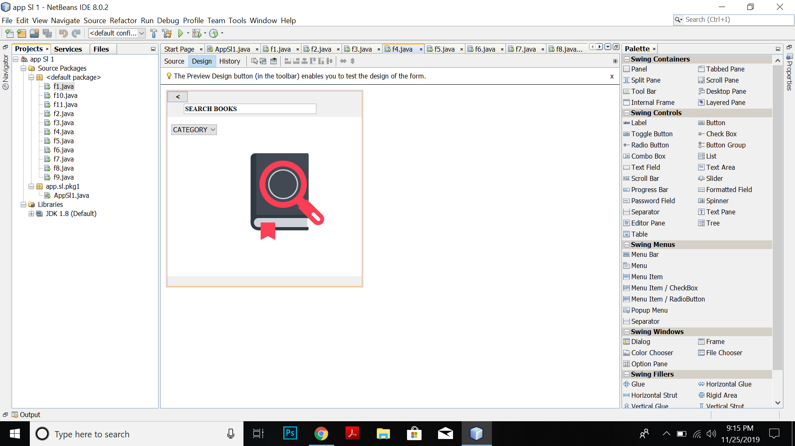 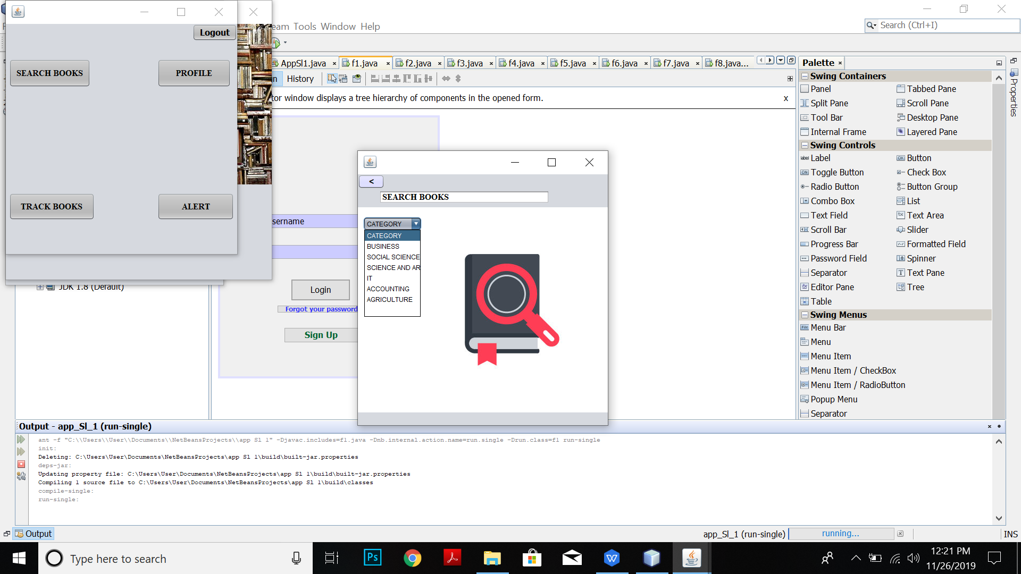

The user can search books by type in search box and also can search in category.

1. **Profile**

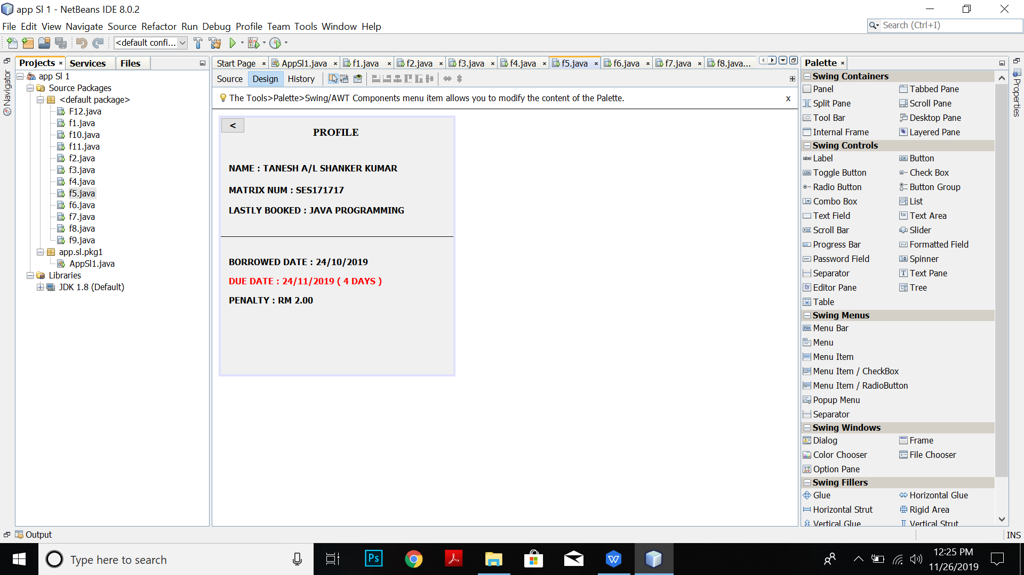

The user who login will have the details in the profile page. There are name, matrix id, lastly booked, borrowed date, due date and penalty.

1. **Track Books**

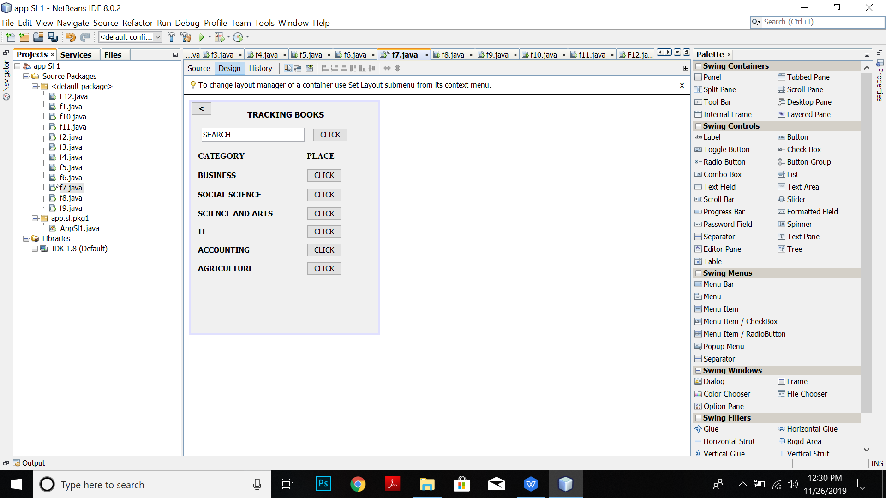

The user can track the books where it placed by click the category or also can search in the search box.

1. **Tracking books**

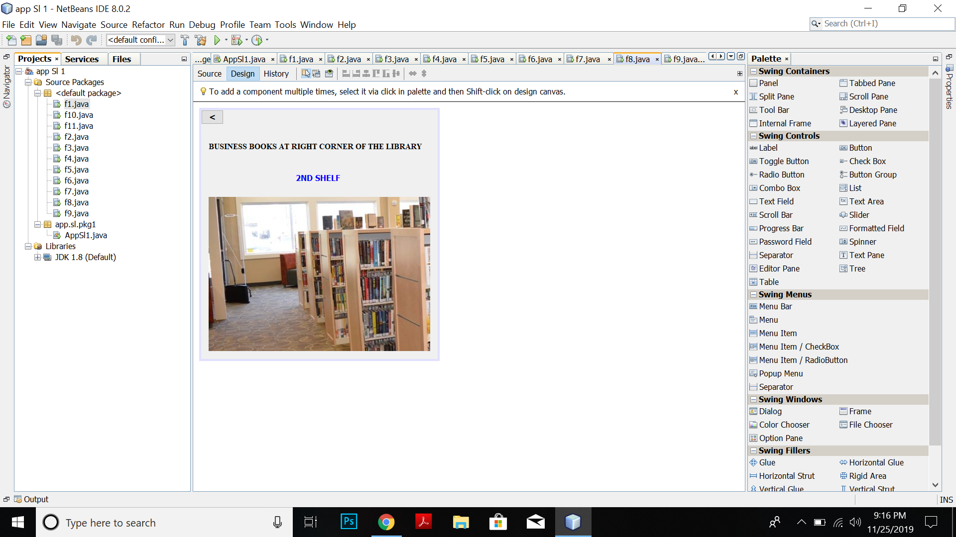

It shows like this if the user track the books by click the place button. It also show in which shelf the category book have.

1. **Alert button**

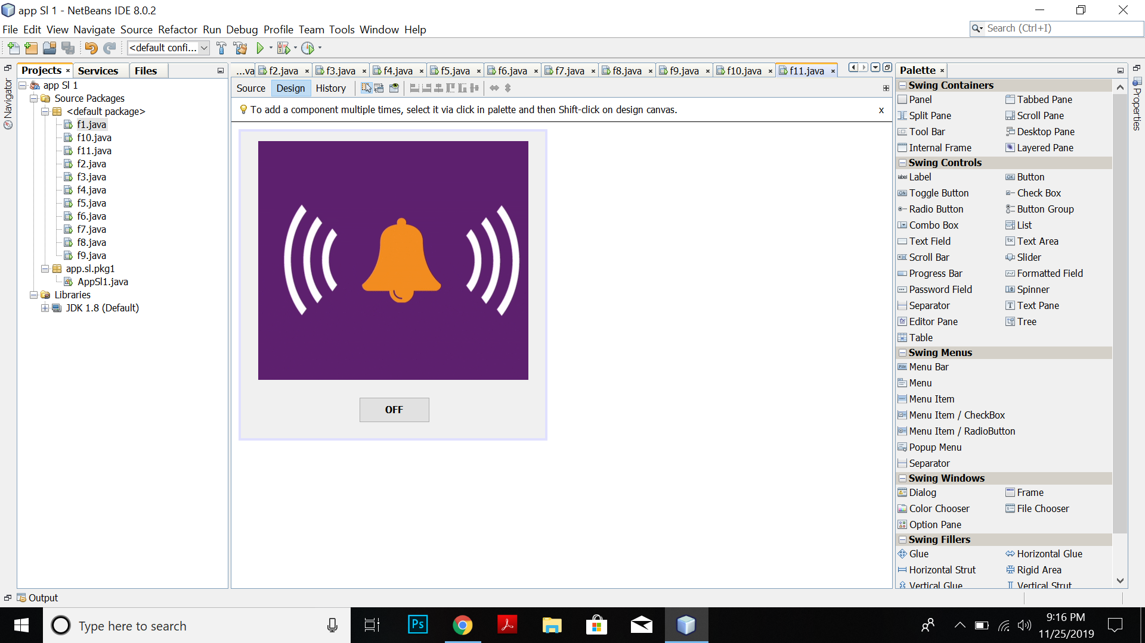

If there more noises, the user can click the alert button. It will give signal to the library staff. Then the user can off it.

1. **Feedback**

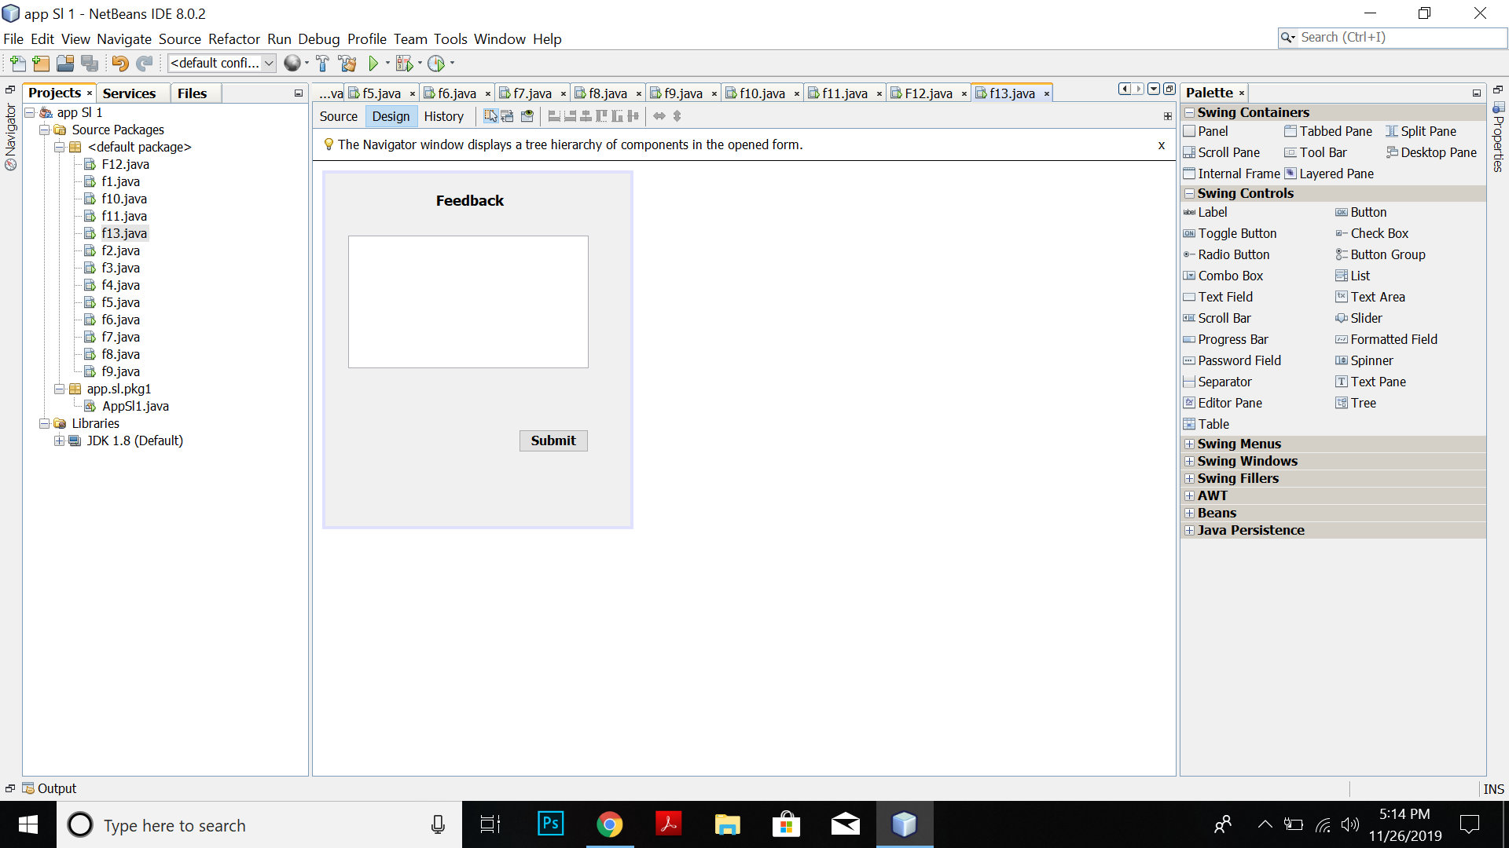

The user can click the report button in the options page and can give their feedback/problem.

1. **Logout**

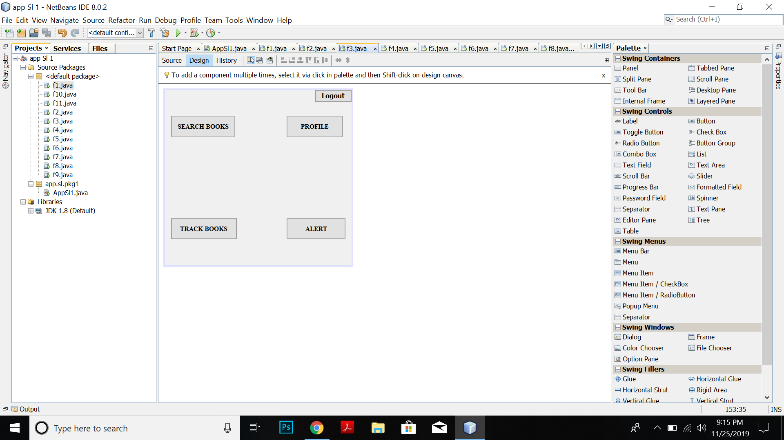 

When the user logout, it will come to the main login page.

**TEST DESIGN**

**Manual Test Cases**

|  |  |  |  |
| --- | --- | --- | --- |
| Test cases | Steps | Expected Results | Status(Fail/Pass) |
| **1** | Enter a valid username and valid password. Click Login button | The application should display the homepage | 50% Pass |
| **2** | Not enter email address when Sign Up account | The application cannot be Sign In | 50% Pass |
| **3** | Choose a category that not in the category list | The application cannot be proceed to next page | Pass |
| **4** | Enter a invalid password and valid password. Click Login button | The application should display an error | Fail |
| **5** | Click the logout button | The application should display to the main login page | Pass |

**Automated Test Cases**